Problem: Happy Lady Bugs

Happy Ladybugs is a board game having the following properties:

* The board is represented by a string, , of length . The  character of the string, , denotes the  cell of the board.
  + If  is an underscore (i.e., _), it means the  cell of the board is empty.
  + If  is an uppercase English alphabetic letter (i.e., A through Z), it means the  cell contains a ladybug of color .
  + String  will not contain any other characters.
* A ladybug is *happy* only when its left or right adjacent cell (i.e., ) is occupied by another ladybug having the same color.
* In a single move, you can move a ladybug from its current position to any empty cell.

Given the values of  and  for  games of Happy Ladybugs, determine if it's possible to make all the ladybugs happy. For each game, print YES on a new line if all the ladybugs can be made happy through some number of moves; otherwise, print NO to indicate that no number of moves will result in all the ladybugs being happy.

**Input Format**

The first line contains an integer, , denoting the number of games. The  subsequent lines describes a Happy Ladybugs game in the following format:

1. The first line contains an integer, , denoting the number of cells on the board.
2. The second line contains a string, , describing the  cells of the board.

**Constraints**

* It is guaranteed that string  consists of underscores and/or uppercase English alphabetic letters (i.e., _ and Athrough Z).

**Output Format**

For each game, print YES on a new line if it is possible to make all the ladybugs *happy*; otherwise, print NO.

**Sample Input 0**

4

7

RBY_YBR

6

X_Y__X

2

__

6

B_RRBR

**Sample Output 0**

YES

NO

YES

YES

**Explanation 0**

The first three games of Happy Ladybugs are explained below:

1. Initial board:   
   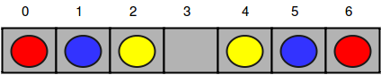  
   After the first move:   
   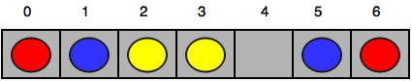  
   After the second move:   
   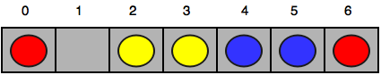  
   After the third move:   
   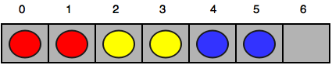  
   Now all the ladybugs are happy, so we print YES on a new line.
2. There is no way to make the ladybug having color Y happy, so we print NO on a new line.
3. There are no unhappy ladybugs, so we print YES on a new line.

Solution

string sort(string &str) //Arranges same color bugs together

{ if(str.find('_')<100) //no empty slot, cannot Move

{ int length=str.length();

for(int i=0; i<length-1; i++)

{ for(int j=0; j<length-1-i; j++)

{ if(str[j]>str[j+1])

{

char temp=str[j];

str[j]=str[j+1];

str[j+1]=temp;

}

}

}

}

return str;

}

//------------------------------------------------------

int happyCheck(string str) //Checks for happy Bugs

{

int length=str.length();

for(int i=0; i<length; i++)

{ if(str[i]!='_')

{ int count=0;

if(i==0 && str[i]==str[i+1]) {count+=1; }

else if(str[i]==str[i+1] || str[i]==str[i-1]){count++;} else if(i==length-1 && str[i]==str[i-1]){count+=1;}

if(count!=1){return 0;} //no happy bug found Abort

}

}

return 1;

}

//-------------------------------------------------

int main()

{

int testCases, size;

string str;

cin>>testCases;

for(int i=0; i<testCases; i++)

{

cin>>size >>str;

(happyCheck(sort(str))==1 ? cout<<"YES" : cout<<"NO");

cout<<endl;

}

return 0;

}

`’ Anshul AgGarwal